AI-DERM VETDOCTOR: DEEP LEARNING FOR SKIN DISEASES

Hridya R P1, Anu Treesa C Y2, Abhinandha P U3, Dina Fathima4,Christeen Paul P Xavier5

*1Assistant Professor, Department of Electronics and Communication Engineering, Universal Engineering College Vallivattom,Thrissur,Kerala,India*

*2,3,4,5 Assistant Professor, Department of Electronics and Communication Engineering, Universal Engineering College Vallivattom,Thrissur,Kerala,India*

*Corresponding Author: Email anutreesacy@gmail.com*

|  |
| --- |
| ***Abstract:*** *AI - Derm VetDoctor, a state-of-the-art device powered by Deep learning and convolutional neural networks, offers swift and accurate diagnosis of skin issues in Cats & Dogs. Its continuous learning from a diverse set of skin images ensures adaptability to new problems. The user-friendly interface allows easy image upload, providing rapid and reliable results for doctors, veterinarians, and individuals. Beyond diagnosis, it serves as an educational hub with resources on various skin conditions, fostering collaboration within the medical community. The platform also promotes proactive skin health management, offering personalized recommendations for skincare and lifestyle adjustments. In essence, AI - Derm VetDoctor is a significant advancement in skin disease diagnosis, enhancing healthcare for people and their pets.*  ***Key Word****:**AI - Derm VetDoctor; Convolutional neural networks; Continuous learning; Adaptability; Proactive skin health management; Educational hub; Personalized recommendations; Lifestyle adjustments; Medical community collaboration* |

1. **Introduction**

AI - Derm VetDoctor not only streamlines the diagnostic process but also serves as an invaluable resource for veterinary education. The platform features a wealth of educational content, including case studies, articles, and tutorials, empowering veterinarians with up-to-date knowledge on emerging dermatological conditions in animals. This emphasis on continuous learning ensures that veterinary professionals stay at the forefront of advancements in the field, ultimately leading to improved care for pets. Moreover, AI - DermVetDoctor fosters collaboration among veterinary practitioners by providing a secure space for sharing insights and seeking advice on challenging cases. This collaborative approach enhances the collective expertise within the veterinary community, contributing to better outcomes for animals facing complex skin issues.

The device’s continuous learning capabilities mean that it evolves with the ever-changing landscape of animal dermatology. This adaptability ensures that veterinarians using AI - DermVetDoctor have access to the latest insights and diagnostic capabilities, enhancing their ability to provide effective and timely treatments for their furry patients .In addition to its diagnostic and educational features, AI - DermVetDoctor promotes proactive pet care. The platform offers tailored remedies and preventive measures based on the specific dermatological conditions identified, empowering pet owners to actively participate in the well-being of their animals. This holistic approach aligns with a growing trend in veterinary medicine, emphasizing the importance of preventive care and early intervention.

In summary, AI - Derm VetDoctor stands as a transformative solution that not only elevates the standard of veterinary dermatology through advanced diagnostics but also contributes to ongoing education, collaboration, and proactive pet care. In doing so, it enhances the lives of both pets and their caregivers, making a significant impact on the overall well-being of our beloved animal companions.

1. **Problem statement**

Veterinary dermatology faces critical challenges in providing timely and accurate diagnoses, particularly in areas with limited access to specialized care. Veterinarians often encounter difficulties in diagnosing complex skin conditions due to rapidly evolving diseases and the lack of collaborative platforms to share expertise. This can lead to delayed treatments, suboptimal care, and recurring issues that affect the well-being of animals.

Additionally, traditional approaches in veterinary care focus more on treating symptoms than addressing underlying causes, often missing the opportunity for preventive care. Pet owners and veterinarians lack user-friendly tools for early detection and tailored treatment plans, further complicating effective skin health management.

AI Derm VetDoctor aims to resolve these issues by providing advanced AI-driven diagnostics, fostering real-time collaboration among veterinary professionals, and offering tailored, holistic treatment solutions. The platform enhances diagnostic accuracy, ensures continuous learning, and promotes proactive care, ultimately improving the overall well-being of animals and elevating the standard of veterinary dermatology.

1. **Block Diagram**

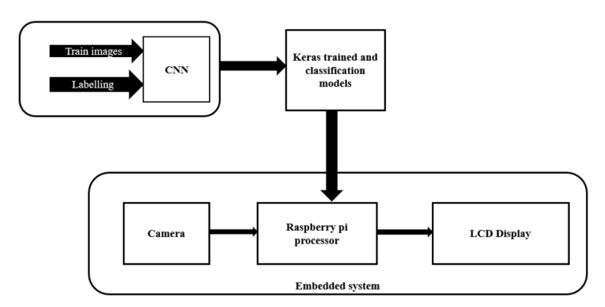

**Block diagram description:**

The training and data labeling process for a set of images are completed before the Convolutional Neural Network (CNN) stage. During the CNN stage, the image undergoes processing with multiple convolution and ReLU layers to extract features relevant to disease classification. After the CNN, we obtain a trained dataset and a disease classification model using Keras. These Keras models are then deployed to a Raspberry Pi processor. Additionally, real-time images of diseased skin can be captured using a camera and fed to the processor. On the processor, the classification and detection of images are performed using the trained model. Based on the classification results, the processor determines the appropriate medicine for the identified disease. Finally, the output is displayed, showing the identified diseases and the corresponding medicine for treatment. This entire process allows for real-time identification of skin diseases in cats and dogs, along with immediate prescription of medicine for their treatment.

1. **Circuit Diagram**

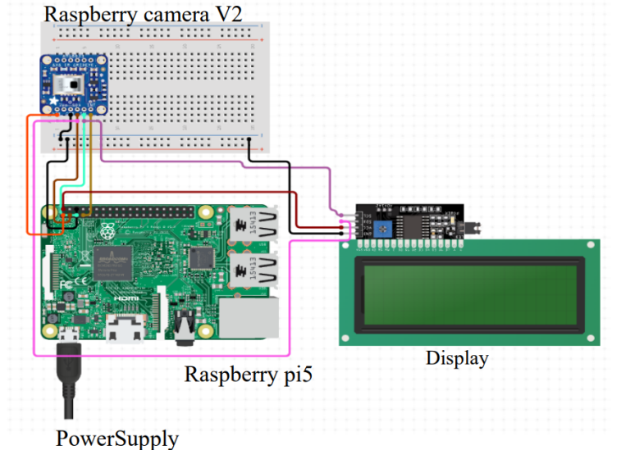

**Circuit diagram description:**

In the hardware component of our project, we primarily use three components: the Raspberry Pi Camera V2, the Raspberry Pi 5 module, and the Raspberry Pi Display. These components are essential for capturing real-time images of diseased skin and processing them for disease classification and medicine prescription. To power the Raspberry Pi 5, we use a 27W USB-C PD Power Supply, ensuring stable and reliable power delivery for optimal performance. The camera is interfaced with the Raspberry Pi 5 using specific connections: 3V power supply (pin 1 to pin 1), SDA (serial data line) (pin 4 to 3), SCL (serial clock line) (pin 5 to 5), GPIO (general-purpose input-output) (pin 6 to 7), and ground (pin 3 to 6). These connections allow the Raspberry Pi 5 to communicate with and control the camera effectively.

Similarly, the display is interfaced with the Raspberry Pi 5 using the following connections: 5V power supply (pin 2 to 3), SDA (pin 3 to 3), SCL (pin 4 to 5), and ground (pin 1 to 6). This setup ensures that the Raspberry Pi 5 can display the output of the classification process in a clear and readable format.

1. **Working**

“AI – DERM VETDOCTOR” is a hardware device specifically engineered for the diagnosis of skin diseases in cats and dogs through the implementation of deep learning, leveraging the Keras algorithm. The device utilizes a built-in camera or imaging technology to capture high-resolution images of skin conditions on animals. These images, meticulously labeled with corresponding skin disease information, form the dataset for training the deep learning model. Employing Keras, a high-level neural networks API, the model, often based on Convolutional Neural Networks (CNNs), is constructed to automatically learn features from input images, making it adapt at image classification tasks. During training, the model adjusts its internal parameters to accurately classify skin conditions. Validation ensures the model’s ability to generalize to new data. In operation, the device accepts images of skin conditions, processes them through the trained neural network, and delivers a diagnosis or classification of the detected disease. The user-friendly interface allows veterinarians or users to input images for analysis, presenting diagnostic results and recommendations based on the identified skin disease. To enhance accuracy over time, the device may incorporate mechanisms for continuous learning, periodically updating the dataset with new cases and retraining the model to stay current with emerging skin conditions. Specific details about the hardware and Keras-based algorithm would require reference to the project’s documentation or direct contact with the developers.

1. **Flow chart**

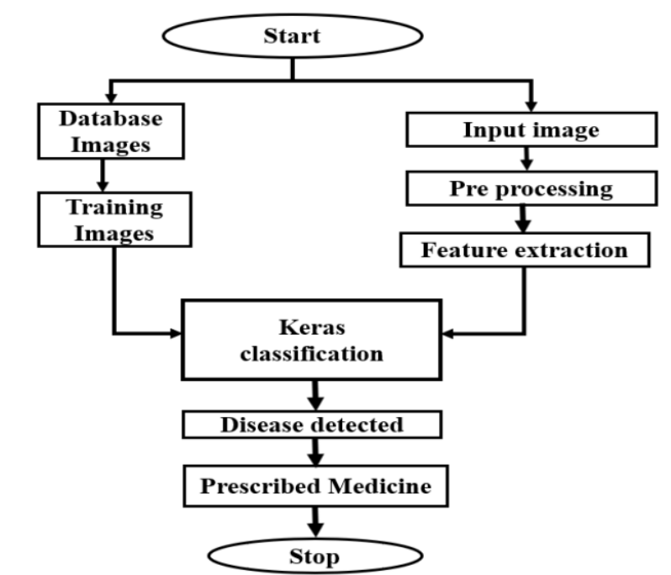

1. **Result**

# Switch on the device

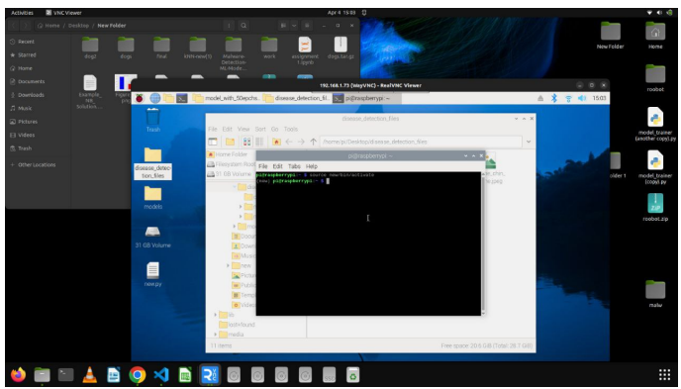

**Selecting the pet (Cat & Dog)**

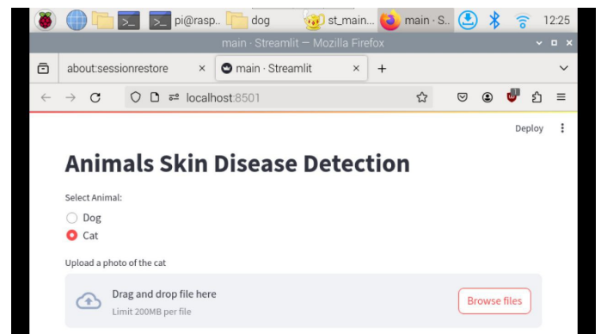

**Capturing the Image**

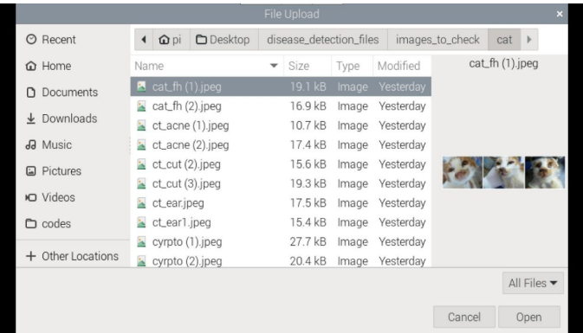

**Predicting the diseases and provide Remedies**

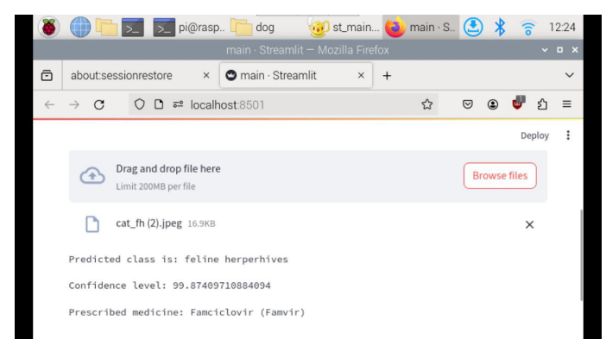

1. **Conclusion**

In conclusion, “AI-DERM VET DOCTOR: DEEP LEARNING FOR SKIN DISEASES” aims to significantly impact the well-being of pets by detecting skin diseases in cats and dogs accurately and prescribing effective medicines. At the beginning of finding the project topic, we looked at many topics but we realized that the statistics of pets, especially stray dogs and stray cats which are not available for treatment at the right time is a problem that no one pays much attention to but it deserves a lot of importance. We found a solution for that problem through deep learning technology, using Keras in CNN skin disease detection and medicine prescription. We have collected many photos of skin diseases of dogs and cats for its data set. In it, 6 classes of dogs and 4 classes of cats were selected as supported format. After doing a lot of processing on it, we got the result with accuracy close to 95%. Although we tried for more accuracy, lack of data availability became an obstacle for us. In hardware section we are using a Raspberry Pi processor and its own HD display. Because of we want a good processor like a mini computer for the image processing and augmentation. Therefore, the pictures given in the input and the medicine prescription shown in the output make the project very simple for user to use. Our marketing plan targets hospitals, doctors, pet care centres and even companies in the pet healthcare and tech sectors. The deep learning technology used in our project emphasis the system’s efficiency , security features, and continuous improvement. The goal is to make it an essential tool for dermatology care. By serving as a self-assessment and potential cost-saving tool, we aim to address the issue of around 200 million pets not receiving timely and correct treatment. This project represents an investment in advancing the veterinary field, offering pet owners peace of mind in caring for their beloved companions

1. **References**

[1] K. D. Miller “AI Cancer treatment and survivorship statistics, 2016,” CA: a cancer journal for clinicians, vol. 66, no. 4, pp. 271-289, 2016

[2] World Health Organization. ”Ultraviolet (UV) Radiation and Skin Cancer.” https://www.who.int/news-room/q-a-detail/ultraviolet-(uv)- radiation and-skin-cancer (accessed 2020)

[3] Australian Institute of Health and Welfare. ”Skin Cancer in Australia.” https://www.aihw.gov.au/getmedia/0368fb8b-10ef-4631- aa14- cb6d55043e4b/18197.pdf.aspx?inline=true (accessed 2020).

[4] N. C. Codella “AI Skin lesion analysis toward melanoma detection: A challenge at the 2017 international symposium on biomedical imaging (isbi), hosted by the international skin imaging collaboration (isic),” in 2018 IEEE 15th International Symposium on Biomedical Imaging (ISBI 2018), 2018: IEEE, pp. 168-172.

[5] M. E. Celebi, N. Codella, and A. Halpern, Dermoscopy image analysis: overview and future directions,” IEEE journal of biomedical and health informatics, vol. 23, no. 2, pp. 474-478, 2019.

[6] A. Krizhevsky, I. Sutskever, and G. E. Hinton, “magnet classification with deep convolutional neural networks,” in Advances in neural information processing systems, 2012, pp. 1097-1105.

[7] T.-C. Pham, C.-M. Luong, M. Visani, and V.-D. Hoang, ”Deep CNN and data augmentation for skin lesion classification,” in Asian Conference on Intelligent Information and Database Systems, 2018: Springer, pp. 573-582.

[8] T. J. Brinker “AI Deep neural networks are superior to dermatologists in melanoma image classification,” European Journal of Cancer, vol. 119, pp. 11-17, 2019/09/01/ 2019, doi: <https://doi.org/10.1016/j.ejca.2019.05.023>.

[9] A. Hekler “AI Deep learning outperformed 11 pathologists in the classification of histopathological melanoma images,” European Journal of Cancer, vol. 118, pp. 91-96, 2019/09/01/ 2019, doi: <https://doi.org/10.1016/j.ejca.2019.06.012>

[10] D.-X. Zhou,”Universality of deep convolutional neural networks” Applied and computational harmonic analysis, vol. 48, no. 2, pp. 787- 794, 2020

[11] Y. Sun, B. Xue, M. Zhang, and G. G. Yen, ”Evolving deep convolutional neural networks for image classification,” IEEE Transactions on Evolutionary Computation, vol. 24, no. 2, pp. 394- 407, 2019.

[12] K. M. Li and E. C. Li “Skin lesion analysis towards melanoma detection via end-to-end deep learning of convolutional neural networks,” arXiv preprint arXiv: 1807.08332, 2018.

[13] P. Tschandl, C. Rosendahl, and H. Kittler,”The HAM10000 dataset, a large collection of multi-source dermatoscopic images of common pigmented skin lesions,” Scientific data, vol. 5, p. 180161, 2018

[14] K. S. Mader. ”Skin Cancer MNIST: HAM10000.” Kaggle. https://www.kaggle.com/kmader/skin-cancer-mnist-ham10000 (accessed 2020).

[15] G. Litjens “AI survey on deep learning in medical image analysis” Medical image analysis, vol. 42, pp. 60-88, 2017.

[16] A. Esteva “AI Dermatologist-level classification of skin cancer with deep neural networks,” nature, vol. 542, no. 7639, pp. 115-118, 2017

[17] Python Software Foundation. ”Python.” https://www.python.org/ (accessed 1 Jun, 2020).

[18] Keras. “Keras.” https://keras.io/ (accessed 1 January, 2020).

[19] TensorFlow. “TensorFlow.” https://www.tensorflow.org/ (accessed 7 July, 2020).

[20] C. Szegedy “AI Going deeper with convolutions,” in Proceedings of the IEEE conference on computer vision and pattern recognition, 2015, pp. 1-9.

[21] S. Han, H. Mao, and W. J. Dally,”Deep compression: Compressing deep neural networks with pruning, trained quantization and huffman coding,” arXiv preprint arXiv: 1510.00149, 2015

[22] F. N. Iandola, S. Han, M. W. Moskewicz, K. Ashraf, W. J. Dally, and K. Keutzer, “SqueezeNet: AlexNet-level accuracy with 50x fewer parameters and¡ 0.5 MB model size,” arXiv preprint arXiv:1602.07360, 2016. [23] Y. Zhu and S. Newsam, “Densenet for dense flow,” in 2017 IEEE international conference on image processing (ICIP), 2017: IEEE, pp. 790-794